The preprocessed dataset is:

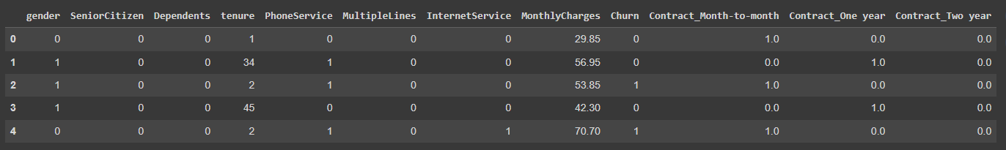

Figure : Preprocessed Dataset

The preprocessed data is separated into two dataframes as X and y, where X is for features and y is for target. The data is split into training and testing dataset X_train, X_test, y_train and y_test. 20% of the data is used for testing and 80% for training.

Figure 2 shows training and testing dataset for feature columns.

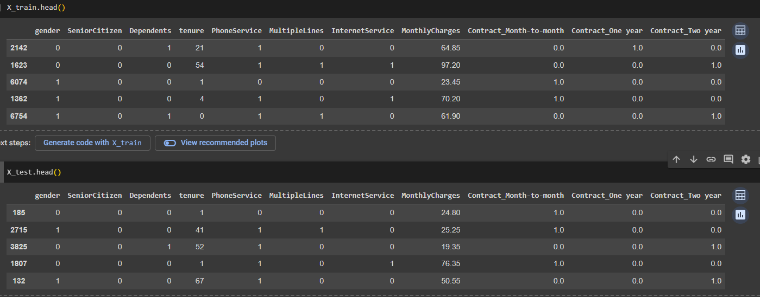

Figure : Training and testing dataset for feature columns

Figure 3 shows training and testing dataset for target column (i.e. Churn)

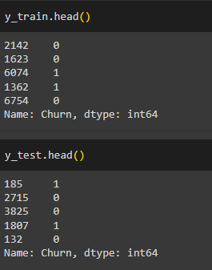

Figure : Training and testing dataset for target column